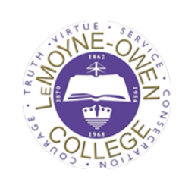
Hollis F. Price Library
Archive(s) Request Form
Requests for materials from the Library/Archive(s) of LeMoyne-Owen College are accepted in person or by email. The requests are answered in the order received and you should receive a response within 72 hours. For questions, comments or concerns, please contact Ms. Townsend at 901-435-1350 jameka_townsend@loc.edu or library@loc.edu.
Name: Click or tap here to enter text.
Address: Click or tap here to enter text.
City: Click or tap here to enter text. State: Click or tap here to enter text. ZIP Code: Click or tap here to enter text.
Phone #: Click or tap here to enter text. E-Mail: Click or tap here to enter text.
Type of record or information: Click or tap here to enter text.
Approximate time period/estimated date of requested records: Click or tap here to enter text.
More Details:
Click or tap here to enter text.

Acknowledgement – Any materials including documents, pictures, texts, etc., pulled from the archive(s) must be given proper credit when/if used for any research, publications or business.
Requester Signature: ______________________________ Date: Click or tap here to enter text.
--------------------------------FOR STAFF USE ONLY------------------------------------------------
Request Received By: Click or tap here to enter text.
Request Processed By: Click or tap here to enter text. Date: Click or tap here to enter text.
Comments:

